Sign-In Sheet Guidance and Training

Early Learning Coalition of Indian River, Martin Okeechobee County

Learning Objectives

Sign In Sheet overview

VPK Guidance
Sign In Sheet
Maintenance

Tips for Sign in Sheet Success
Payment Validation Guidance

Sign In/ Out Overview

• Format for Sign in/out Sheets:

• Name of Provider (match name on issued license or license exempt letter)

• Name of child (match name on the Early Learning Coalition’s Enrollment
Certificate)

• Dates including the Month and Year

– Acceptable examples include: 2/12/21 or Feb 12, 2021

– Unacceptable examples include: Friday or 12

• Time in

• Time out

• AM and PM must be specified if the provider offers night care

• Siblings must have individual sign in/out sheets.

Sign In/ Out Overview

• Signature Guidance:

• Clear Full Signature (First and Last Name) of the parent or person authorized by the parent to drop off/pick up the child. Signature should be legible or match the parent’s/authorized guardian’s government issued ID.

– Avoid using:
– First name only, ex: Stacy
– First name with last initial, ex: Stacy S
– Last name only, ex: Smith
– Last name with first initial, ex: S Smith
– Initials only, ex: SS
– Relationship to child only, ex: Mom
– Symbols or single letters only, ex: X or

Sign In/ Out Overview

• In the event that the provider signs a child in and out, the provider must maintain supporting documentation to support this occurrence. These documents may be requested during a PAAM audit.

• Examples include:

– A staff member of the provider is listed as an authorized person to pick up or drop off in the child’s file.

– A driver’s log if the provider transports the child to and from the facility. This log must be in accordance with rule 65C-22.001, F.A.C., which indicates that the driver adheres to the following steps:

– Mark each child off the log as the children depart the vehicle

– Sign, date and record the driver’s log immediately

– Upon arrival at the destination, a second staff member shall sign, date and record the driver’s log immediately, verifying that all children were accounted for and that the log is complete.

Sign In/ Out Overview

• Electronic Sign In/Out Sheet Rules:

• All of the above rules apply.

• Providers may not enter parents’ codes for sign in or sign out purposes. This can be considered fraud.

• It is best practice to have parent/guardian/ authorized person review, sign and date a print- out of the electronic sign in/sign out sheet at the end of every month.
• Afterschool Sign In/ Out Sheet Rules:

• School-age children who are picked up at school and transported by the Provider must be signed in by the Provider upon arrival each day and signed out by the parent.

• School-age children that attend for before and aftercare must have two signatures for the day on their sign in sheet (One signature when parent drops child off at the provider for before care and second signature when parent picks child up from aftercare).

– Provider should also sign the child out when the child goes to school in the morning and then sign them back in when the child arrives after school. This totals four signatures each day.
– For example: 6:03am- signed in by parent
7:48am- signed out by provider
3:43pm- signed in by provider
5:10pm- signed out by parent

• School- age children may not sign themselves in or out, even if they walk home. In this case, the provider may sign the child out with parent permission.

Maintaining Sign In/ Out Sheets

• Sign-in/out sheets for the current month must be in use and on-site. All children who are present must be signed in. If the child has left for the day, the child should be signed out. If the child is absent, the sign-in sheet should be blank or indicated as “absent.” The Coalition can only authorize reimbursement for children who are accurately signed in and out daily.

• Sign-in/out sheets for the current fiscal year must be on-site and accessible during normal business hours for unannounced audits. Accessible is defined as providing the sign-in/out sheets to the Coalition while the Specialist is on-site unless otherwise specified. Providers must ensure that staff in charge in their absence have access to all sign-in/out sheets, current and past.

• Sign-in/out sheets requested for Post Audit Attendance Monitoring (PAAM) must be submitted upon request to the Coalition. If the Provider maintains past sign-in sheets off-site, the Provider must submit the sign-in sheets via E-file Cabinet by the 3rd business day.

• Sign in/out sheets for School Readiness, Voluntary Prekindergarten providers must be maintained for a minimum of five (5) years after the expiration of the Provider Contracts.

Payment Validation Guidance

• Discrepancy, requiring an adjustment is an inability to determine whether the child was present after reviewing the attendance sheet and sign in/out sheets. Providers are allowed three absences no questions asked, all discrepancies are effective after the three allowable absences.
• Examples of discrepancies requiring an adjustment include, but are not limited to:
– Child marked present on the attendance sheet, but not signed in and out on the sign in sheet.
– Child marked present on the attendance sheet but sign in and sign out signatures are crossed out.
– Child marked present and signed in and out by the provider, with no supporting documentation that the provider was authorized to do so.
– Using an electronic sign in/out system a child was signed in and out by the provider evidenced by use of the provider code, with no supporting documentation that the provider was authorized to do so.
– Child was signed in by provider but not signed out by anyone and the provider did not transport the child to the facility.
– School age child is signed in by provider and signed out by child, without proper transportation documentation.
– Any day(s) for which a sign in/out sheet was not submitted.
• An Error occurs when a child’s attendance is not in question however there is an error/mistake in the completion of the forms.
• Examples of errors include, but are not limited to:
– Child signed in but not signed out, child signed out but not signed in.
– Child signed in and/or out using initials or last name only.
– Time in and/or out is missing or is rounded.
– Child signed in/out on a day coded as a holiday.
– Child’s name does not match records.
– Examples include:
– ELC Certificate states “Timothy”, but the sign in sheet states “Timmy”.
– ELC Certificate states “Keon Smith”, but the sign in sheet states “Kion Smith”.
– ELC Certificate states “Jonathan Jackson Jr”, but the sign in sheet states Jonathan Jackson”.
– Provider name is not listed on sign in/out sheets, short forms or long forms.
– Provider name on the sign in/out sheet, short form or long form does not the match Health Department license.
– Year and/or month not on the sign in/out sheets.
– AM/PM not on sign in/out sheets for providers approved for night care, additional documentation may be requested.
– Child was signed in/out, but the attendance sheet has a blank spot.

Tips for Success

• Ensure sign in/out requirements are included in the informational packet provided to all parent/guardian/person authorized at your center, family child care home, school, summer camp and/or afterschool program.

• Review procedures with parents, and other persons authorized for dropping off and picking up children regularly.

• Review sign in/out sheets on a regular basis to ensure all requirements are being met.

• Portal attendance is prepopulated with “X” s. It is your responsibility to adjust codes as necessary, including approved holidays on your contract.

VPK Guidance

• VPK Providers must ensure that in addition to daily sign in/out sheets, Parent/guardian/ authorized person must verify the students’ attendance each month, on the prior month’s certified student attendance, Short Form.

• VPK Providers that use a method other than a daily sign in/out sheet, such as attendance logs, the provider must ensure that parents certify the students’ attendance each month using the Long Form.

• Short and Long Forms must be signed and certified by the parent/guardian/person authorized no earlier than the last school day of the month and no later than ten (10) calendar days into the following month.

– For example: The month of August 2021 can be verified and signed between the days of August 31 and September 10.

VPK Guidance

• Discrepancies for VPK:

• Child marked present on the attendance sheet but is not indicated as present on the VPK Long Form.

• VPK Long Form is not signed and certified by the parent, no earlier than the last school day of the month and no later than ten (10) calendar days after the end of each month into the following month.

• VPK Long form is signed, dated, and certified by parent before the end of the month. Any days after the sign date cannot be validated and monies will be deducted.

• Child marked present on the attendance sheet, but not signed in and out on the sign in sheet.

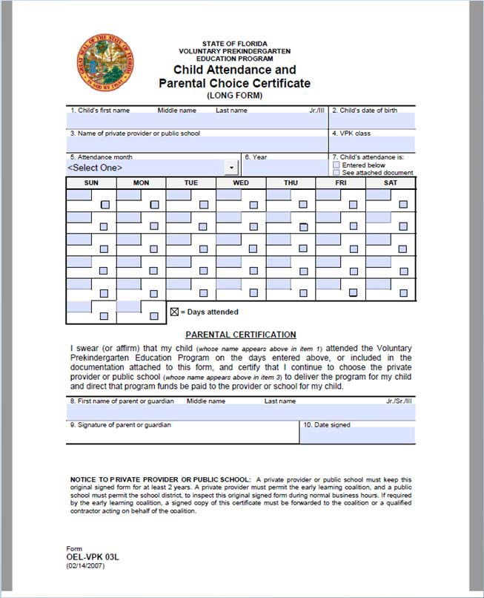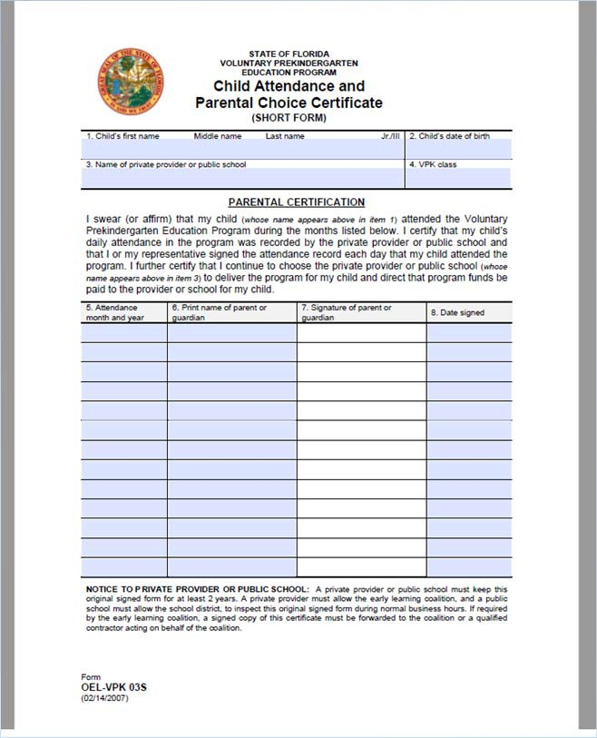

VPK Guidance: Examples

Short Form Long Form

